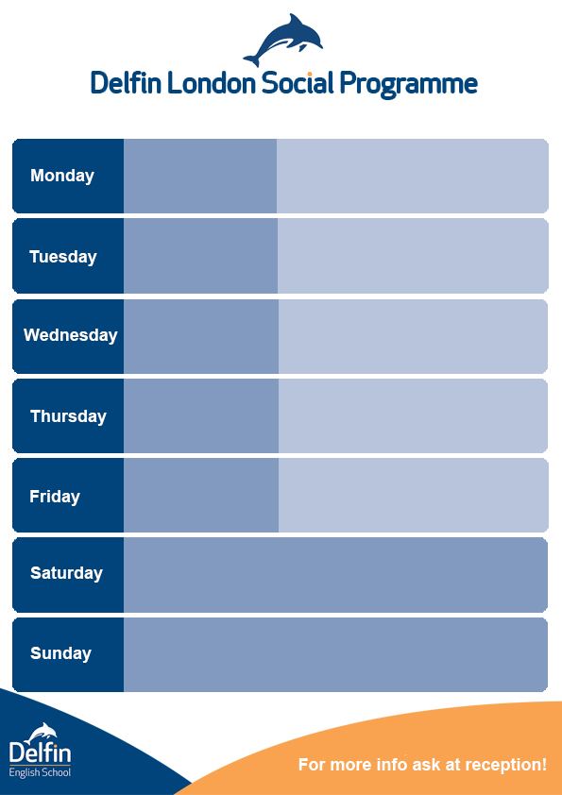lf

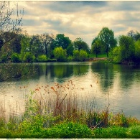

**04th – 08th March**



**Writing and speaking test**

**Welcome Tea Party**



**From 12:30 – 13:30 in the   
Delfin Lounge**



**Come with your friends to cook some pancake during shorves day**

Delfin lounge @17:30

**Pancake Day!**

**With Matt**

**Come to discover this wonderful part of London.   
We might eat something there!**

**Reception @ 14:30**

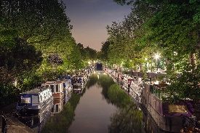

**The Little Venice**

**With Paulyne**



**Job Session  
  
With Kasia**

**Get your English CV corrected!**

**Your CV must be PRINTED !**

**Delfin Lounge @ 17:30**



**International Women’s Day !**  
Share some famous women you know in the Delfin Lounge!

**Tropicana Beach Club**

Start the weekend in style  
**18+ Only**

**Weekend Tours on Saturday and Sunday £10 Discount: Use special code delfin10** [**www.andersontours.co.uk**](http://www.andersontours.co.uk)



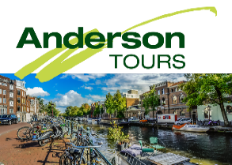

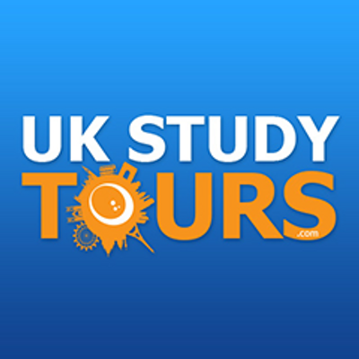



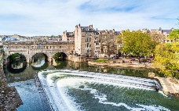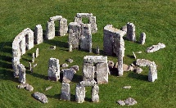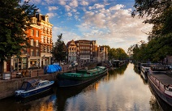

**Bath Cambridge Stonehenge Amsterdam Paris Edinburgh**

**Don’t forget to take lots of pictures. Follow and tag delfinschool on**



